Prototype RWIS Alert System Design

Hayden Pride, Nicholas Steilman, and Quinn Cox
Software Engineering Students
Computer Science Department
Montana Technological Institute

Douglas Galarus
Associate Professor, Computer Science Department
Montana Technological Institute

A report prepared for the

ESOF 486 – ESOF 487, Senior Design at Montana Tech

(Revised December 2, 2025)

DISCLAIMER
The opinions, findings, and conclusions expressed in this publication are those of the authors and not necessarily those of Montana Technological University. For further information contact Douglas Galarus, Department of Computer Science, Montana Technological University, 1300 West Park Street, Butte, MT, 59701, telephone number 406-496-4858, email address dgalarus@mtech.edu.

ACKNOWLEDGEMENTS
The authors are thankful to past members of the WeatherShare Project for their input and review of prior versions of this document. This document was written by Nick Steilman, Hayden Pride, and Quinn Cox at the University of Montana Tech for Senior Software Engineering Design, ESOF 486-487. We are thankful to the staff and students at the Western Transportation Institute at Montana State University and students at Utah State University for their contribution to the WeatherShare application which inspired this project. We are also thankful to the students who worked with Dr. Galarus on previous senior design projects for their contributions to this project. Special thanks to Dr. Galarus who both inspired this project as well as acting as a mentor for the senior design team. We acknowledge and thank the California Department of Transportation (Caltrans) and the Western States Rural Transportation Consortium (WSRTC) for their sponsorship of the WeatherShare project.

Table of Contents
1. INTRODUCTION 8
1.1 Purpose 8
1.2 Scope 8
1.3 Senior Design Project Scope 8
1.4 Definitions, Acronyms, and Abbreviations 8
1.5 References 8
1.6 Overview 8
2. OVERALL DESCRIPTION 10
2.1 Product Perspective 10
2.1.1 System Interfaces 10
2.1.2 User Interfaces 10
2.1.3 Hardware Interfaces 10
2.1.4 Software Interfaces 10
2.1.5 Communications Interfaces 11
2.1.6 Memory Constraints 11
2.1.7 Operations 11
2.1.8 Site Adaptation Requirements 11
2.2 Product Functions 11
2.3 User Characteristics 12
2.4 Constraints 12
2.4.1 Regulatory Policies 12
2.4.2 Hardware Limitations 12
2.4.3 Interfaces to Other Applications 12
2.4.4 Parallel Operation 12
2.4.5 Audit Functions 12
2.4.6 Control Functions 12
2.4.7 Higher-order Language Requirements 12
2.4.8 Signal Handshake Protocols 13
2.4.9 Reliability Requirements 13
2.4.10 Criticality of the Application 13
2.4.11 Safety and Security Considerations 13
2.5 Assumptions and Dependencies 13
3. DESIGN BY SPECIFIC REQUIREMENTS 14
3.1 User Accounts, Authentication 14
3.1.1 Authentication 14
3.1.2 User (Responsibility) Scopes 14
3.1.3 User Roles 14
3.1.4 Access 14
3.1.5 User Notification 14
3.1.6 Disabling User Accounts 15
3.1.7 Deleting User Accounts 15
3.1.8 User Preferences 15
3.2 RWIS Data 17
3.2.1 Data Retrieval 17
3.2.2 Data Processing 18
3.2.3 Data Storage 19
3.2.4 Presentation 20
3.3 Alerts 20
3.3.1 Alert Definition 20
3.3.2 Alert Evaluation and Actuation 22
3.4 Performance Requirements 23
3.4.1 Updating and Delivery Frequency 24
3.4.2 Reliability 24
3.4.3 Maintainability 24
3.4.4 Performance Requirements 25
3.4.5 Non-Functional Requirements 25
3.5 Application Requirements 25
3.5.1 General 25
3.5.2 Data Format and Standards 26
3.5.3 Interface Display 27
3.5.4 Control 27
3.6 Enabling Requirements 28
3.6.1 Installation Design 28
3.6.2 Documentation 29

List of Figures

Figure 1: ERD representing simple table structure for user information and alert definitions 16
Figure 2: Flow diagram displaying the management flow of user authentication and account management. 17
Figure 3: Example wireframe for a login page where the user will be directed to before being able to view their saved alerts. 18
Figure 4: Example wireframe for configuring an alert with conditions and general information. 19
Figure 5: Example wireframe displaying the history of triggered user-defined alerts. 20
Figure 6: Wireframe detailing the Data Retrieval process for measured data from Caltrans. 21
Figure 7: Wireframe displaying RWIS data processing flow. 22
Figure 8: Example raw CSV data from CWWP2 portal 23
Figure 9: Example flow of Flat file storage process. 24
Figure 10: Example data conversion using Python functions. 25
Figure 11: Example wireframe displaying the alert definition flow. 27
Figure 12: Example wireframe showing an administrative alert management webpage. 28
Figure 13: Example Table displaying alert definitions. 28
Figure 14: Example alert defined for Bogard. 29
Figure 15: Example wireframe displaying the flow for Alert evaluation and actuation. 30
Figure 16: Example view of defined alerts for Bogard. 31
Figure 17: Flow displaying the data retrieval process from the Web application. 35
Figure 18: Example raw CSV Data from CWWP2 online portal. 36
Figure 19: Flow displaying the data normalization of CSV data. 37
Figure 20: Example post-processed CSV data with converted units. 38
Figure 21: Flow describing the architecture for the web-based application. 40

1. INTRODUCTION

Purpose
The purpose of the Prototype RWIS Alert System Design Document is to describe how the system will implement the functionality defined in the Software Requirements Specification (SRS). This design document translates the requirements into technical implementation details for developers and reviewers.

Scope
The Prototype RWIS Alert System is a standalone application focused on processing Caltrans RWIS data to generate condition-based alerts. The design defines how the system retrieves processes, stores, and evaluates RWIS data, as well as how users interact with alerts through a web interface.

Senior Design Project Scope
This project is being developed as part of the Montana Tech Senior Design project, with the goal of building a functional prototype that processes RWIS data directly from CSV files. The prototype consists of a Python-based backend for data retrieval and conversion to “human-friendly” units, a PHP-driven web interface for user interaction, alert evaluation, and an SQLite database for managing users, alert definitions, and alert states.

The system enables users to define customizable alerts for environmental variables such as air temperature, wind speed, and precipitation levels. Each alert is evaluated automatically as the new data is retrieved. Active alerts are displayed through the web interface and recorded in the system’s database. While this prototype demonstrates complete alert creation and evaluation functionality, external subscription and notification features (such as email or SMS delivery) are outside the scope of this project.

Definitions, Acronyms, and Abbreviations
The following abbreviations are used in this document:

Caltrans California Department of Transportation
CWWP2 Caltrans Commercial Wholesale Web Portal Version 2
ITS Intelligent Transportation Systems
MADIS Meteorological Assimilation Data Ingest System
MSU Montana State University
NTCIP National Transportation Communications for Intelligent Transportation System Protocol
RWIS Road Weather Information System
SRS Software Requirements Specification
TCP Transmission Control Protocol
WTI Western Transportation Institute

References
The following project documents were used to develop this document:
- WeatherShare System Design, Good D., Gutierrez S., Pflug S. November 13, 2024
- Prototype RWIS Alert System Software Requirements Specification (SRS) by Pride, H., Steilman, N., Cox, Q. October 31, 2025

Overview
This document is organized as follows:

- Chapter 2, presents the overall system description
- Chapter 3, presents the design corresponding to each requirement

Mock diagrams are included to illustrate data flow and system structure.

OVERALL DESCRIPTION

Product Perspective

System Interfaces
The system shall interface with the following components and data sources:
- Caltrans CWWP2 RWIS CSV Feed, to provide atmospheric and surface sensor readings and metadata for California RWIS sites

- PHP Web Application to facilitate user authentication, alert management, and tabular data presentation via browsers

User Interfaces
The system shall include the following user interfaces:
- Web-based interface for authenticated users to view current RWIS data, define alerts, and monitor active conditions via browsers
- Web-based interface for unauthenticated users to view current RWIS data and monitor active alerts via browsers
- Administrative dashboard for system management tasks such as user control and log inspection
- SSH access for administrators to perform server-level maintenance and configuration

Hardware Interfaces
There are no specific non-standard hardware interfaces. The System is designed to operate on any standard web server capable of running Python and PHP.

Software Interfaces
The system shall be implemented using Linux, Apache, PHP, and Python with SQLite for data persistence. Key interfaces include:
- Python for data retrieval and alert evaluation
- PHP for web application logic and session management
- SQLite as the relational database engine
- HTML, CSS, and JavaScript for front-end presentation

Communications Interfaces
The system shall use standard TCP/IP communications.

Memory Constraints
There are minimal memory requirements, and they are intended to run within standard web server configurations. The SQLite database is expected to remain small since the system stores only recent data. These measures ensure that the application remains lightweight and efficient even when operating over extended periods.

Operations
The system will generally operate in the same manner for all users. All data retrieval and alert evaluation tasks are automated and occur on scheduled intervals. Users interact through the web interface to view data, define alerts, and observe current conditions.

Site Adaptation Requirements
There are no anticipated adaptations for client use of the system. The System will use a web-based client that will run on standard, current, and future browsers with Internet access.

Product Functions
The following general functionality summarizes the capabilities of the Prototype RWIS Alert System:
- Retrieval of RWIS sensor values from Caltrans CWWP2 CSV feeds
- Parsing and validation of CSV data to extract key parameters
- Local storage of processed sensor readings in structured SQLite tables
- User-defined alert creation supporting comparison operators
- Automated alert evaluation and state management
- Web-based display of current and recent RWIS data in tabular format
- Logging of data retrieval, alert evaluation, and system events
- Administrative tools for user and alert management

User Characteristics
Users include public users who can view the alerts and RWIS data, general users who configure and view alerts, and administrators who manage users and system operations.
- Public users view RWIS data and active alerts via web browsers
- General users define and view alerts for selected RWIS parameters using the web interface. They require a simple and intuitive interface for monitoring data and alert activity
- Administrators maintain system operations, manage user accounts, and monitor logs and data retrieval processes

Constraints

Regulatory Policies
The system shall conform to applicable Montana Technological University policies for data use, security, and accessibility.

Hardware Limitations
Not applicable; the System has no unique hardware signal or timing constraints.

Interfaces to Other Applications
The system operates independently and interfaces only with Caltrans RWIS CSV data from the Caltrans CWWP2.

Parallel Operation
The System shall operate in a multi-process fashion, where data retrieval and alert evaluation run concurrently without delays to user interaction.

Audit Functions
The System shall log its operation into a user-readable, text-based format, including timestamps for retrieval and alert evaluation.

Control Functions
Administrative functions include creation, disabling, deletion, and log review.

Higher-order Language Requirements
The System shall be implemented in Python and PHP, with HTML/CSS for interface and SQLite for storage.

Signal Handshake Protocols
Not applicable.

Reliability Requirements
The System shall continue operation if a data feed is temporarily unavailable and automatically resume retrieval when connectivity is restored.

Criticality of the Application
The prototype shall be capable of continuous operation for testing and demonstration purposes but may be paused for maintenance without data loss.

Safety and Security Considerations
Public access will be allowed for viewing only. Administrative access shall be restricted to authenticated users through a secure login interface. User credentials are encrypted, and all communications use HTTPS where possible.

Assumptions and Dependencies
The System assumes reliable availability of Caltrans CWWP2 CSV feeds, functional network connectivity, and a properly configured web server environment supporting PHP.

DESIGN BY SPECIFIC REQUIREMENTS

User Accounts, Authentication

Authentication
3.1.1.1 There shall be authenticated and non-authenticated access to The System.
3.1.1.2 Non-authenticated users shall be identified as public users and shall have limited access to view RWIS and alert content only.
3.1.1.3 Authenticated users shall log in using username/password credentials managed in the SQLite database.
3.1.1.4 User authentication will be implemented through PHP session management. Passwords will be securely hashed using industry-standard algorithms.

User Roles
3.1.3.1 Users shall have one of three possible roles either public or administrator.

Access
3.1.4.1 Users shall access The System via web browser.

3.1.4.2 Users shall access The System exclusively via the Internet.

User Notification

3.1.5.1 Notification will not be handled by The System, but The System will facilitate the potential for notification via the alert system.

Disabling User Accounts
3.1.6.1 There shall be a mechanism for disabling user accounts.

3.1.6.2 Users shall not be able to log onto The System if their account is disabled.

3.1.6.3 There shall be a mechanism for re-enabling User accounts.

3.1.6.4 User defined alerts shall be disabled if the corresponding account is disabled.

Deleting User Accounts
3.1.7.1 There shall be a mechanism for deleting user accounts.

3.1.7.2 Users shall not be able to logon to The System if their account is deleted.

User Preferences

3.1.8.1 Users shall be able to save user preferences.

3.1.8.2 User preferences shall include the default display of data.

Design
User accounts will be managed through PHP and SQLite. Authentication is handled via PHP sessions, with credentials stored in hashed form within the database. When users log in, the system validates credentials, creates a session, and loads user-specific configurations such as alert definitions and preferences. Administrative functionality allows authorized users to add, disable, or delete accounts through a secure interface.
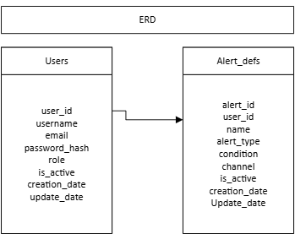
Figure 1: ERD representing simple table structure for user information and alert definitions

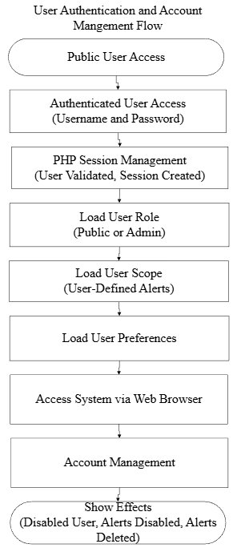
Figure 2: Flow diagram displaying the management flow of user authentication and account management.

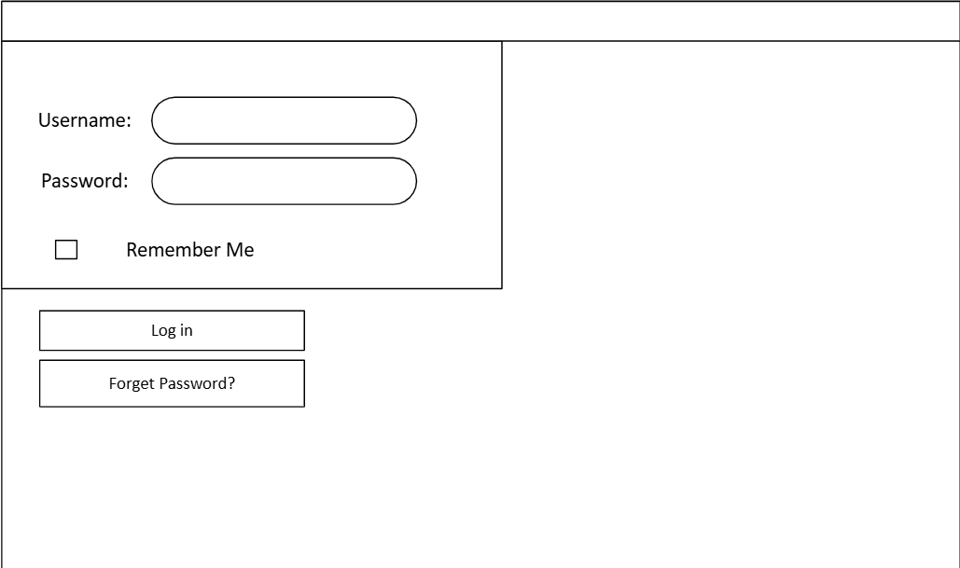
Figure 3: Example wireframe for a login page where the user will be directed to before being able to view their saved alerts.

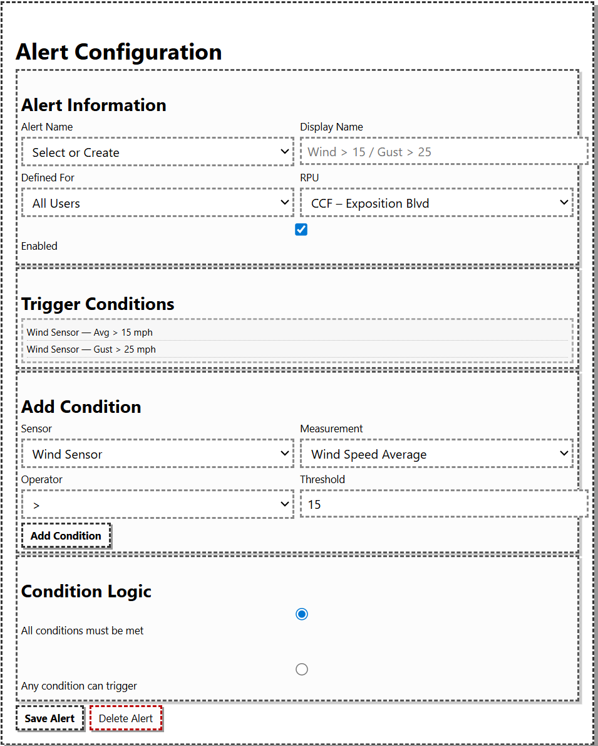
Figure 4: Example wireframe for configuring an alert with conditions and general information.
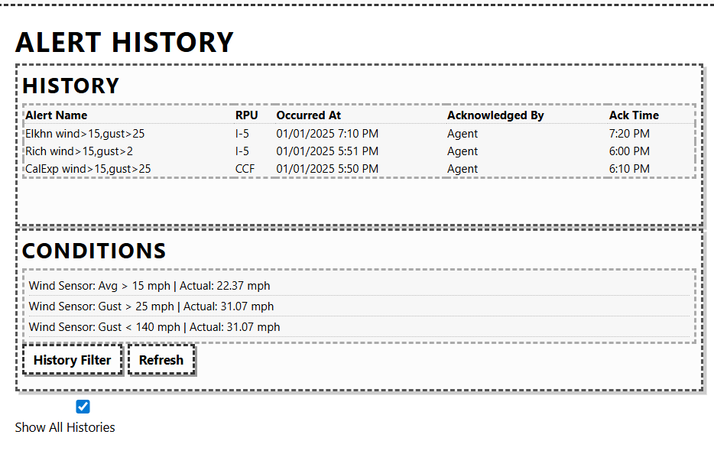
Figure 5: Example wireframe displaying the history of triggered user-defined alerts.

RWIS Data

Data Retrieval

      - The System shall retrieve data from the CWWP2 online portal from Caltrans.
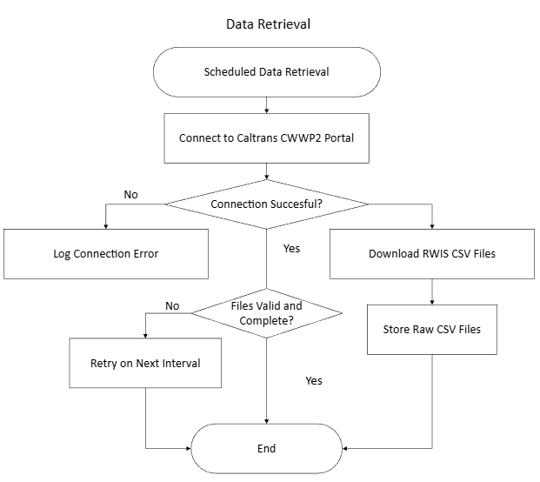
Figure 6: Wireframe detailing the Data Retrieval process for measured data from Caltrans.

Design
The following flow diagrams show the proposed processes for RWIS data retrieval:

Data Processing
3.2.2.1 The System shall read retrieved RWIS data into memory for processing.

3.2.2.2 The System shall add processed data into a temporary data file until all sensor readings have been processed.

3.2.2.3 The System shall export the processed data into a flat file for use, display, and storage once all retrieved data has been processed.

Design
The System will load retrieved RWIS CSV data into memory using a Python Pandas data frame. As each row is validated and converted into standardized formats, the processed values will be appended to a temporary in-memory structure. Once all sensor readings have been processed, The System will export the finalized processed dataset into a flat file for downstream storage, tabular display, alert evaluation, and any additional system components requiring uniform processed data.
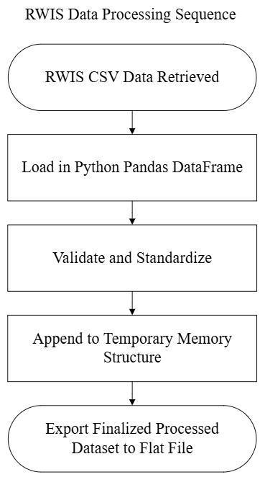
Figure 7: Wireframe displaying RWIS data processing flow.

Data Storage
3.2.3.1 The System shall store only the most recent data in a flat file. The System shall store RWIS data in a CSV flat file format.

Design
The System will store the most recently processed RWIS data in a single CSV flat file that is regenerated during each update cycle. After the data processing stage is completed, the finalized dataset will overwrite the existing flat file to ensure that only the most current sensor readings are retained. This approach minimizes storage requirements, simplifies downstream data access, and ensures consistent formatting for display alert evaluation, and other system components that rely on the latest RWIS values.

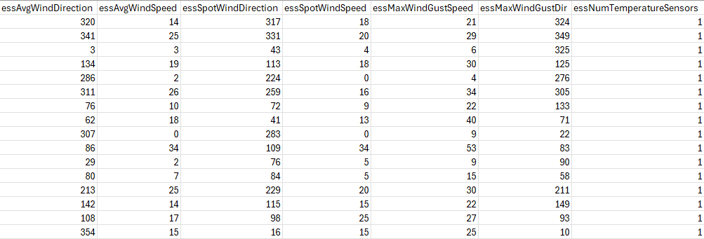
Figure 8: Example raw CSV data from CWWP2 portal

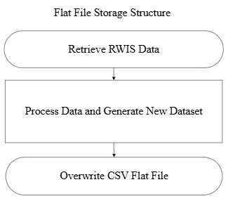
Figure 9: Example flow of Flat file storage process.

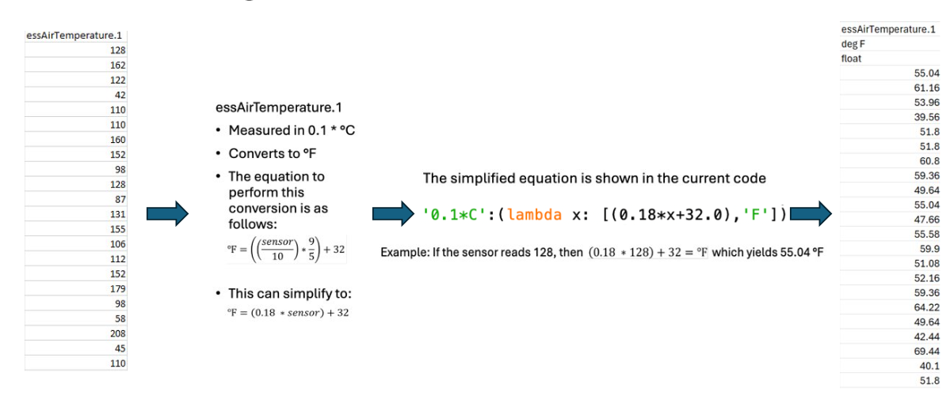
Figure 10: Example data conversion using Python functions.

Presentation
3.2.4.1 Users shall be able to view current conditions as reported by RWIS via a tabular interface.

Alerts

Alert Definition
3.3.1.1 Alerts shall be exclusively defined based on RWIS data.

3.3.1.2 Alerts shall be defined based on single or multiple conditions.

3.3.1.3 Conditions shall be defined based on individual RWIS sensor readings.

3.3.1.4 Conditions shall be defined using comparison operators: less then, less than or equal to, equals, greater than or equal to, and greater than.

3.3.1.5 Alerts shall be defined to include a short (20 characters or less) name.

3.3.1.6 Alerts shall be defined as including a short (100 characters or less) description.

3.3.1.7 Authenticated users shall be able to define alerts for their individual use.

3.3.1.8 There shall be a mechanism for deleting alerts.

Design
Alerts will be defined and stored within the System’s SQLite database, with each alert containing user-provided metadata and a set of one or more logical conditions derived exclusively from RWIS sensor readings. Conditions will be presented internally as structured comparison expressions, each referencing a specific RWIS parameter and a comparison operator. The System will enforce length limits for alert names and descriptions during creation to ensure consistent formatting. Authenticated users may create alerts through the web interface by selecting one or more sensor conditions, providing name and description fields, and saving the alert to their personal collection. The System will provide an interface for users to view, modify, and delete their alerts, with deletions removing the associated alert record and its condition definitions from the database.
The following figure shows the data structures for alert definition, evaluation and the various interactions between these data structures. As shown, there are many components involved, and the overall process is complex compared to others in the system.

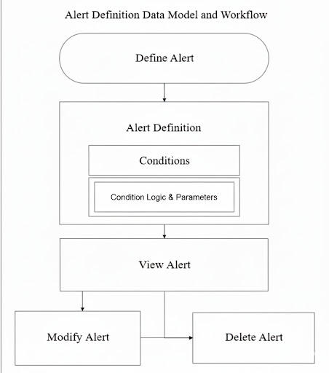
Figure 11: Example wireframe displaying the alert definition flow.

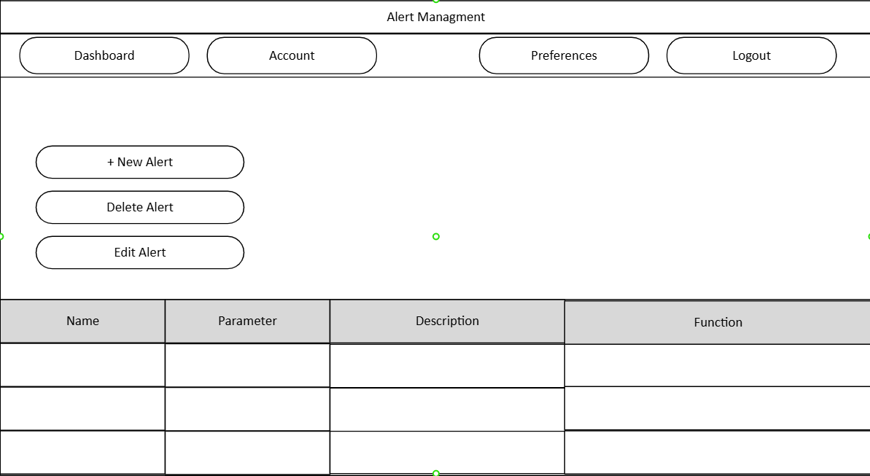
Figure 12: Example wireframe showing an administrative alert management webpage.

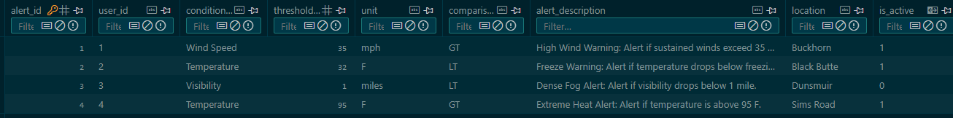
Figure 13: Example Table displaying alert definitions.

Alert Evaluation and Actuation
3.3.2.1 Alert conditions shall be evaluated when new RWIS sensor readings are read by The System.

3.3.2.2 Alerts shall be actuated when their defining conditions are satisfied.

3.3.2.3 A clear alert shall immediately be de-actuated, regardless of valid duration.

3.3.2.4 The System shall evaluate user-defined alerts when applicable sensor readings are updated.

3.3.2.5 The System shall actuate alerts for which alert conditions are satisfied.

3.3.2.6 The System shall log results of alert evaluations.

Design
The System will evaluate all user-defined alert conditions each time new RWIS sensor readings are ingested and processed. During evaluation, the Python alert engine compares current sensor values against each alert’s set of conditions, actuating any alert whose conditions are fully satisfied. The evaluation process is triggered automatically during every data update and is applied only to alerts referencing the sensors that were updated. After all evaluations are completed, the System records results, including actuation, and unchanged states.
The following figure shows the process for alert evaluation and actuation.

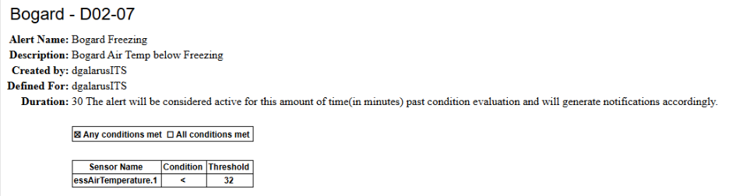
Figure 14: Example alert defined for Bogard.

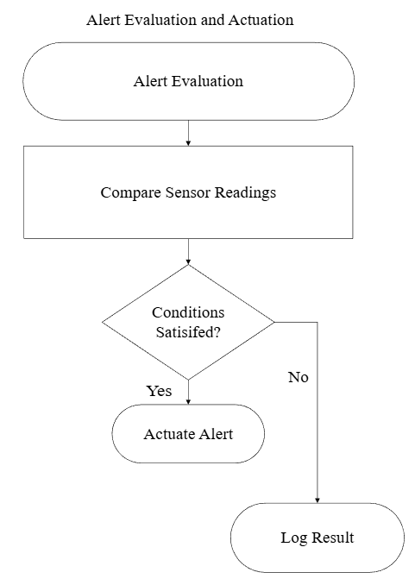
Figure 15: Example wireframe displaying the flow for Alert evaluation and actuation.

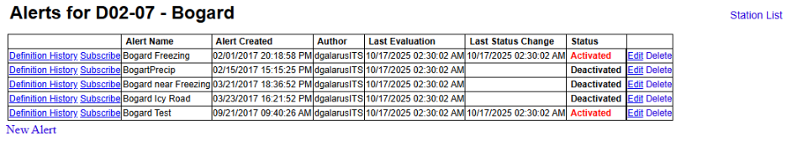
Figure 16: Example view of defined alerts for Bogard.

Performance Requirements
Performance requirements refer to measurable system capabilities. This section includes discussions of the updating and delivery frequency requirements for the website.

Updating and Delivery Frequency
3.4.1.1 The System shall retrieve new data from external sources to correspond with update schedules for those sources.

3.4.1.2 The System shall recognize and immediately process data retrieved by The System from external sources.

3.4.1.3 The System shall recognize and immediately process data pushed to The System by information relay devices.

Reliability
3.4.2.1 In the event of inoperable communication between The System and data sources, The System shall continue to operate.

3.4.2.2 The System shall display a warning to users if connectivity to a data source has been lost.

Maintainability
3.4.3.1 Upon the addition, modification, or deletion of alerts, The System shall not require significant alteration (no system reboot or recompilation of source code is required).

3.4.3.2 The System shall not require a reboot for addition or modification of data or alerts.

3.4.3.3 The RWIS Subsystem shall be runnable for development and testing purposes on development machines with local copies of data.

3.4.3.4 The RWIS Subsystem shall read, extract, preprocess, and store data in a way that is intuitive and easy to manage.

3.4.3.5 The RWIS Subsystem shall be structured in a way that is easy to modify for future applications.

3.4.3.6 The RWIS Subsystem shall be modular, facilitating code-reuse, configuration, and unit-testing.

Performance Requirements
3.4.4.1 The map-based user interfaces and data acquisition shall automatically refresh every five minutes.

Non-Functional Requirements
3.4.5.1 The System shall be structured in a manner such that a backup mechanism for the server can easily back up system data and that The System can be readily restored from such backups.

3.4.5.2 The user interface shall allow the user to intuitively select objects on the computer screen by point-and-click manipulation with a pointing device.

Application Requirements

General
3.5.1.1 The application shall be available via commonly available, recent versions of web browser software running on a desktop or laptop PC platform.
3.5.1.2 The application shall be housed on a local server.
3.5.1.3 The application shall pull in data from specific sources and provide that data to user groups via web-based protocols.
3.5.1.4 The application shall receive data from specific sources and provide that data to user groups via web-based protocols.

Design
The application will be hosted on a local server running Apache, allowing authenticated users to access system functionality through standard, modern desktop web browsers without requiring client-side installation. The System will retrieve RWIS data from designated external CSV sources using scheduled Python processes and make this data available to users through PHP-generated web pages using standard HTTP protocols. All data retrieved or processed by the System will be delivered back to users through the same web interface in formatted tables or alert displays, ensuring consistent, browser-based access to recent RWIS information.

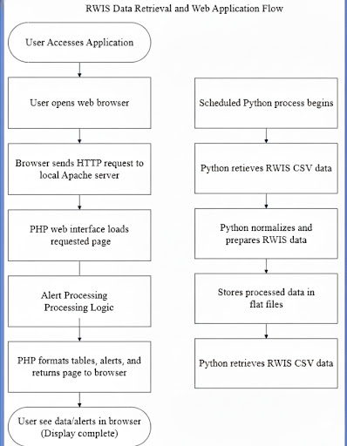
Figure 17: Flow displaying the data retrieval process from the Web application.

Data Format and Standards
3.5.2.1 The application shall be capable of reading all data formats of the supplying agencies.

3.5.2.2 The application shall store RWIS data in a format compatible with NTCIP 1204, Environmental Sensor Station Interface Standard 3,4,5

Design
The application will be designed to read RWIS data in the CSV formats supplied by Caltrans, ensuring compatibility with all variations of the CWWP2 export structure. During ingestion, Python processing scripts will normalize incoming fields into a consistent internal schema. Processed RWIS readings will be stored in a standardized, NTCIP-compatible format within the System’s flat files and database structures, enabling consistent interpretation of sensor types, units, and values across all system components and support alignment with industry environmental sensor station standards.

Figure 18: Example raw CSV Data from CWWP2 online portal.
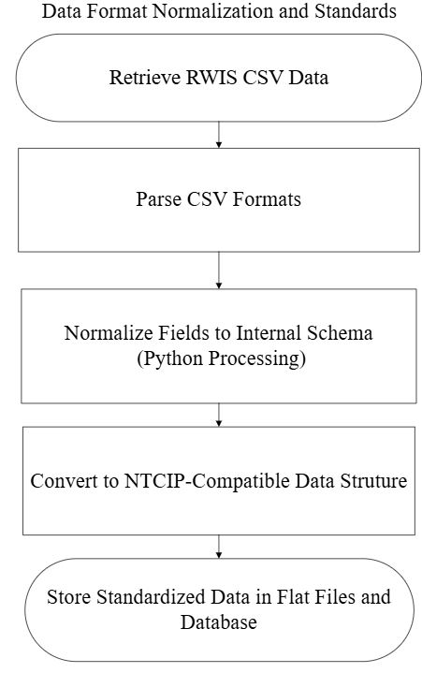
Figure 19: Flow displaying the data normalization of CSV data.

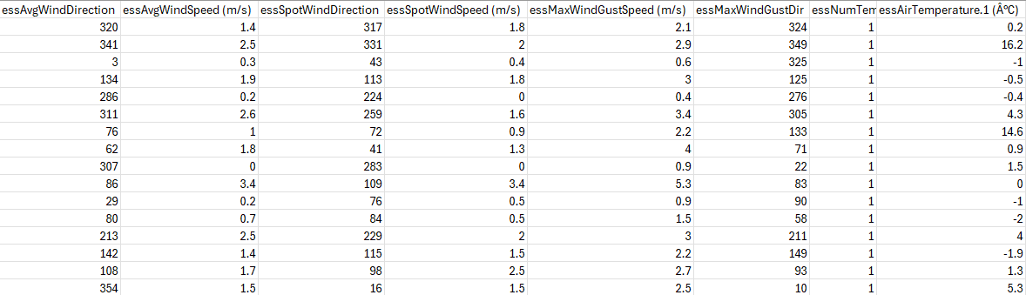
Figure 20: Example post-processed CSV data with converted units.

Interface Display
3.5.4.1 The application shall include tabular elements.

3.5.4.2 The application shall be designed such that it is clear to the user that a data element is missing or unavailable.

Control
3.5.5.1 The application shall require interaction on the part of the user.

Enabling Requirements

Installation Design
3.6.1.1 The application shall operate in a standard web browser and be designed such that access may be accomplished by the user via a website link, with no software installation required.

Design
The application will be deployed on a local server configured with Apache, PHP, Python, and SQLite, allowing users to access the System through a standard web browser without requiring any client-side installation. All functionalities will be provided through web pages accessible via a direct URL link. Installation consists of placing the Python data-processing scripts, PHP web interface files, and establishing scheduled tasks for RWIS data retrieval. No additional software or plugins will be required on the user’s computer.

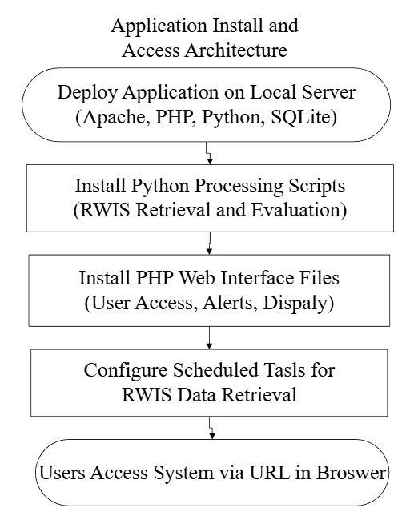
Figure 21: Flow describing the architecture for the web-based application.

Documentation
3.6.2.1 Documentation pertaining to the development and coding of the application shall be compiled by the 2025 Montana Tech senior design team.

3.6.2.2 Documentation pertaining to the RWIS Subsystem shall be revised by the Montana Tech Senior Design Team.

3.6.2.3 The application shall include a “Help” link to assist the user in using the application.

Design
All technical documentation for the application will be produced by the 2025 Montana Tech Senior Design Team. Updates and revisions to RWIS Subsystem documentation will also be completed by the team to reflect the design, capabilities, and operational processes of the prototype system. The application will include an integrated “Help” link within the web interface that directs users to a locally hosted help page containing instructions for navigating the system, defining alerts, viewing RWIS data, and performing administrative tasks.

